In a proactive move to bolster pedestrian safety, California has introduced Assembly Bill 413 (AB 413), a landmark piece of legislation aimed at improving crosswalk visibility through a practice known as “daylighting.” This bill represents a significant step forward in reducing pedestrian accidents and enhancing overall road safety.
Understanding Daylighting
Daylighting involves the strategic removal of parking and other obstructions from the areas surrounding crosswalks. By creating clear sightlines between drivers and pedestrians, daylighting ensures that both parties have adequate visibility of one another, reducing the likelihood of accidents. Essentially, it is about ensuring that drivers can see pedestrians approaching or crossing the street from a distance, thus allowing them to react in time.
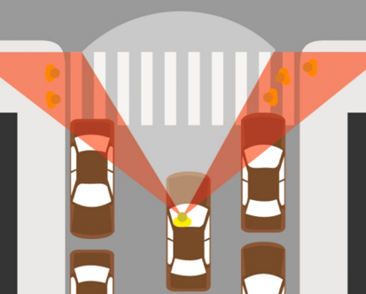
Before daylighting: cars cannot see pedestrians in the crosswalk due to parked cars blocking the sightlines.

After daylighting: cars have a clear view to pedestrians before they step off the curb into the crosswalk.

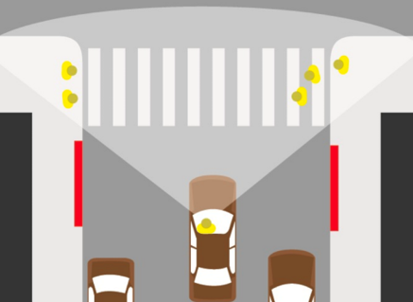
How AB 413 Enhances Safety
Crosswalks situated near intersections with limited visibility are often hazardous, especially for children, the elderly, and those with disabilities. By requiring municipalities to clear visibility zones around crosswalks, AB 413 aims to:
- Reduce Blind Spots: Vehicles often have large blind spots, especially in urban settings with dense traffic and parking. Daylighting helps mitigate these issues by removing obstacles that block drivers' views of pedestrians. Specifically, AB 413 prohibits stopping, standing, and parking within 20 feet of both marked and unmarked crosswalks or intersections. Additionally, the bill bans parking within 15 feet of fire hydrants or driveways. This clear space helps eliminate common visual barriers and ensures better sightlines for drivers and pedestrians alike.
- Improve Driver Awareness: With unobstructed views, drivers are more likely to spot pedestrians in time to stop or slow down. This heightened awareness can lead to more cautious driving behaviors around crosswalks.
- Enhance Pedestrian Safety: Pedestrians will benefit from improved visibility as they cross streets, reducing their risk of being involved in accidents.
What the Public Should Know
- Parking Regulations: Residents and drivers should stay informed about new parking restrictions around crosswalks. Specifically, AB 413 prohibits stopping, standing, and parking within 20 feet of both marked and unmarked crosswalks or intersections, and 15 feet from fire hydrants or driveways. Changes may include new signage or altered parking zones.
- Community Impact: Local governments will work to ensure that daylighting improvements are implemented with minimal disruption. Community feedback may be sought to address specific concerns.
- Safety Benefits: Understanding that these changes are designed to protect both pedestrians and drivers can foster greater community support and cooperation.
California’s Daylighting Bill (AB 413) is aimed at enhancing crosswalk safety and reducing pedestrian accidents. By removing obstructions and improving visibility, the legislation represents a significant step toward safer streets for everyone. Public awareness and adherence to new regulations will be key in making this vision a reality.
